**Smart Farmer-IOT Enabled Smart Farming Application**

**Project Development Phase**

|  |  |
| --- | --- |
| **Team ID** | PNT2022TMID14849 |
| **Project Name** | Smart Farmer-IOT Enabled Smart Farming Application |

**Sprint Delivery -2**

**Software:**

1. **Create device in the iot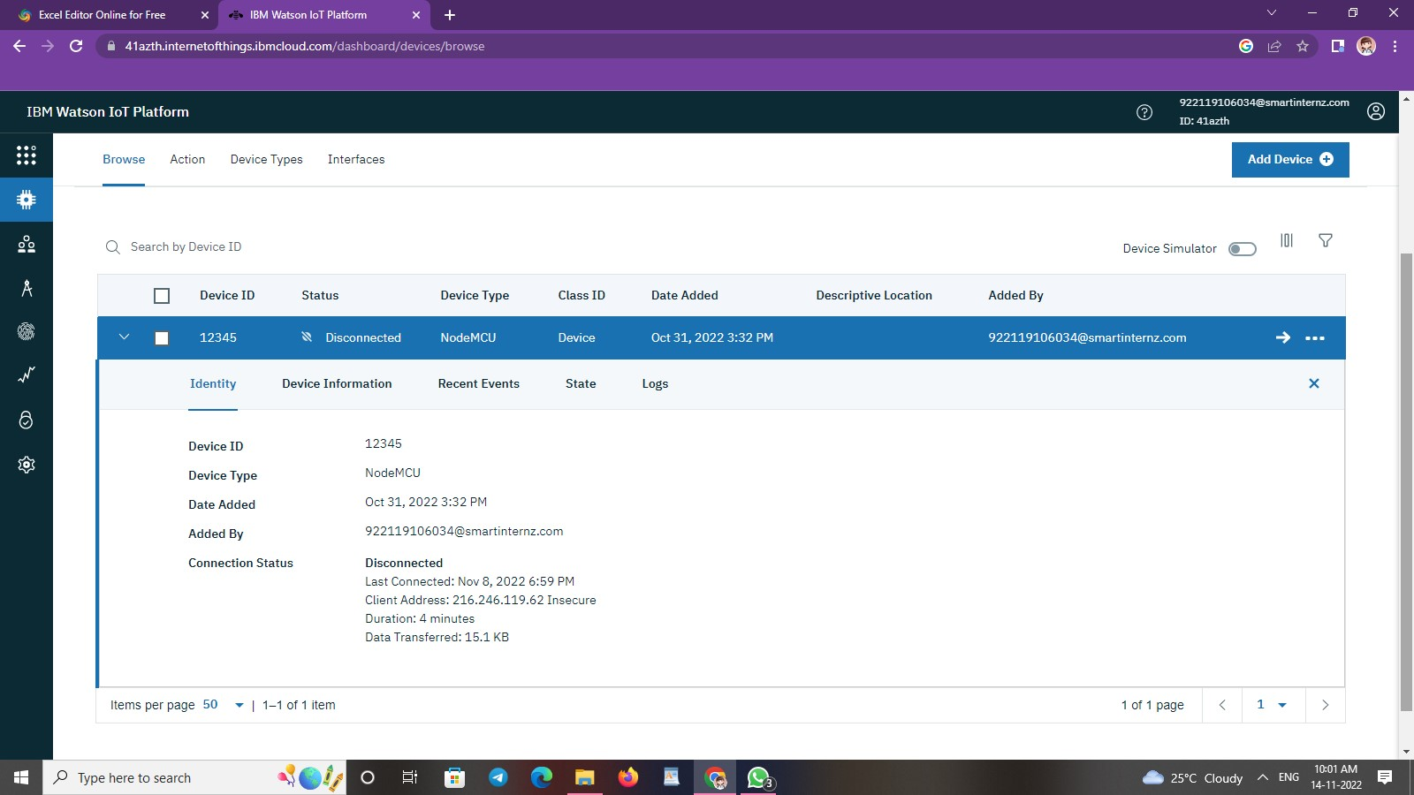 watson platform:**

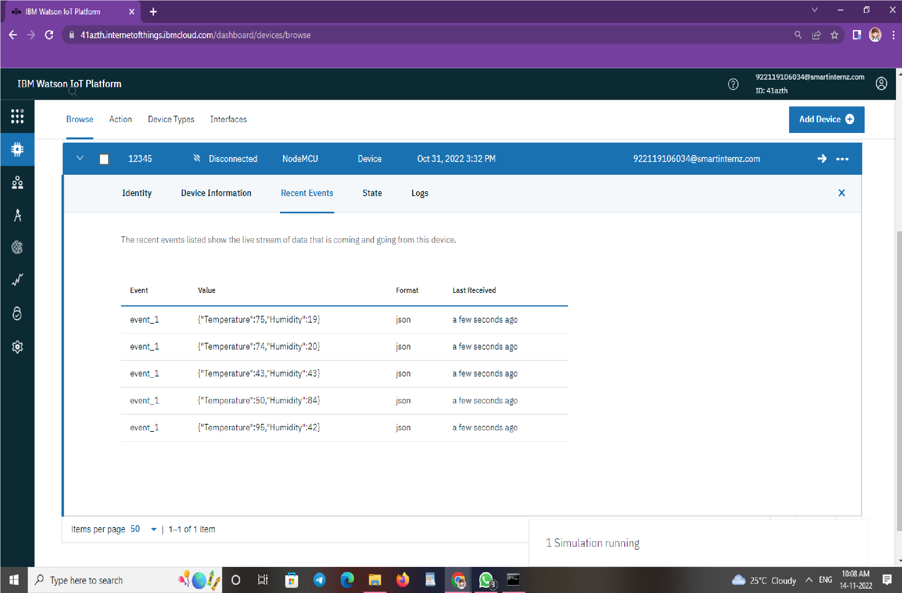

1. **Workflow for iot scenarios using local node red:**

